Project Design Phase-II
Technology Stack (Architecture & Stack)

Date | 01 Nov 2025
Team ID | NM2025TMID01600
Project Name | Laptop Request Catalog Item
Maximum Marks | 4 Marks

Technical Architecture:
The Deliverable shall include the architectural diagram as below and the information as per the table1 & table 2
Example:
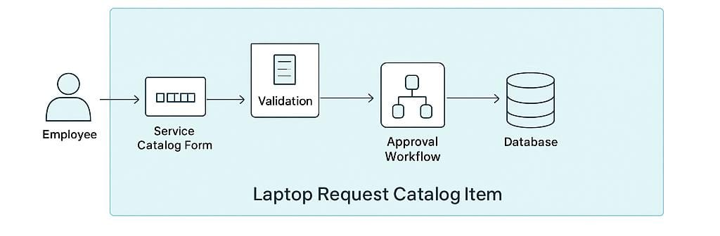
Guidelines:
- Include all processes (Form submission, Validation, Approval, Fulfillment).
- Clearly separate user-facing components and backend logic.
- Show data storage (Update Sets / Tables).
- Indicate integration with email notifications and workflow automation.
- Demonstrate cloud hosting under ServiceNow SaaS platform.

Table-1 : Components & Technologies:

S.No | Component | Description | Technology
1. | User Interface | Employee interacts through Service Catalog Form in ServiceNow.
  ServiceNow Service Catalog UI
2. | Application Logic-1
  Validates form inputs and ensures required fields are completed.
  Catalog Client Script
3. | Application Logic-2 | Applies UI Policies to dynamically show/hide variables.
  UI Policies
4. | Application Logic-3 | Handles request submission and triggers approval workflow.
  Flow Designer
5. | Approval Workflow | Routes the request to the manager for approval.
  ServiceNow Flow Designer
6. | Notification Engine | Sends automated emails on submission, approval, and completion.
  ServiceNow Notification Engine
7. | Database
  Stores catalog request data and fulfillment status.
  ServiceNow CMDB / Task Tables
8. | Cloud database
  Managed within the ServiceNow SaaS environment.
  ServiceNow Cloud Database
9. | File Storage
  Stores attachments like approval justifications or request details.
  ServiceNow Attachments
10. | Infrastructure (Server / Cloud) | Hosted and managed on the ServiceNow Cloud platform | ServiceNow SaaS Cloud

Table-2: Application Characteristics:

S.No | Characteristics | Description | Technology
1. | Open-Source Frameworks | Not applicable (ServiceNow is proprietary SaaS platform) | -
2. | Security Implementations | Role-based access for users, managers, and IT staff. | ACLs, Scoped Applications
3. | Scalable Architecture | Can be extended to include other catalog items (like Desktop or Accessories). | ServiceNow Cloud Architecture
4. | Availability | Highly available with ServiceNow cloud hosting | Load-balanced ServiceNow Instances
5. | Performance | Optimized using asynchronous flows and indexed task tables. | Flow Designer, Background Scripts

